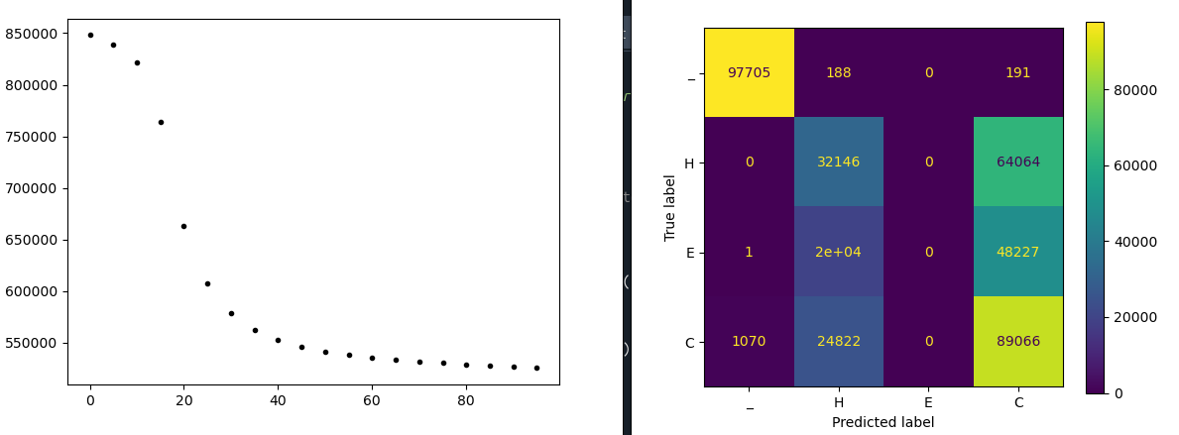
2025 06 26

with following features I got a “real” level of performance (low, of course)
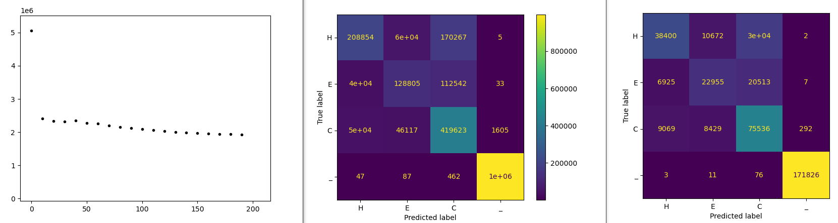

1. found bug that put an extra AA #20 (V) at end of all sequences. This was from the ‘\n’ at end of each record, and the .find() returning -1. solved by putting the space ‘_’ at end, so A is first and space is last.

2. switched to centering sequence in sequence space(using f'{clss[:maxLen]:^{maxLen}}' ) this puts equal space padding on each end.

Q: could this help as my padding puts zeros which are not spaces? Can test by setting maxlength to larger than max sequence size.

Just changing maxlength from 400 to 520, using a dataset with seq lengths 100 to 400, seems to make it WORSE! Is this real or just random? Is it the imbalance of the spaces?

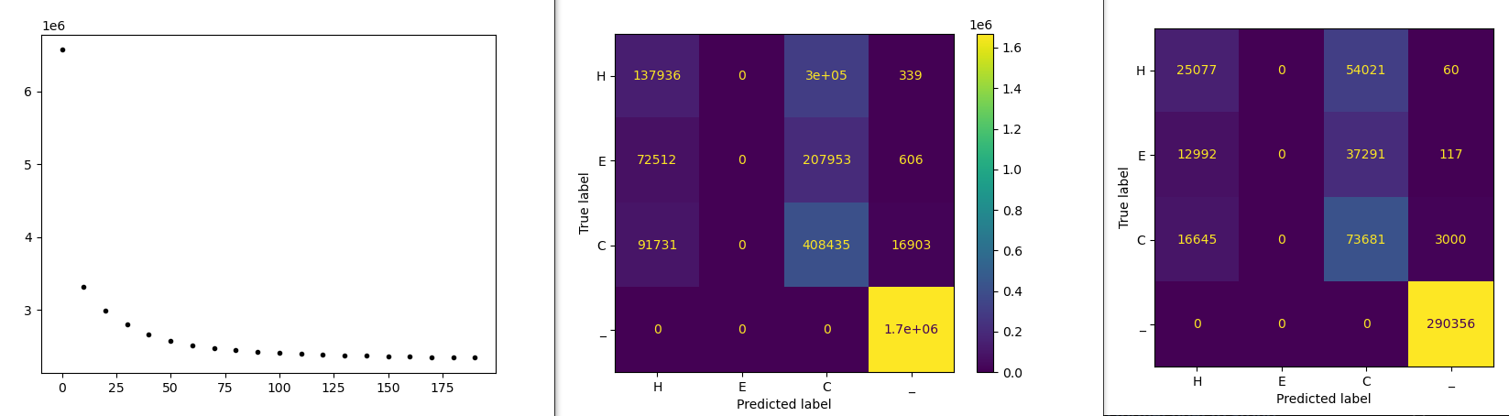

One experiment could be using sequences that completely fill the sequence frame. Say, use sequences from 200 to 400, but fit into

